Sidem Solution: ball joint with patented design

Ball joints are often to be pressed into the control arm for installation. But if this part already has been replaced before, the material of the control arm will be stretched. Sidem developed a patented solution for this problem: easy to install, safe and with a high wear and tear resistance.

Certain Dacia, Lada, and Renault models have a control arm with a press ball joint. Pressing this in the control arm with each replacement, can stretch the material of the control arm. Result? You cannot safely install and secure the ball joint. Worst case scenario is that you are forced to order an entire new control arm and replace it completely. But if the control arm is still in good condition, you must only replace the ball joint.

Unique ball joint with patented design
Thanks to our extensive know-how and high-quality materials, Sidem was able to come up with a solution for the press ball joint problem and has developed a unique and patented ball joint that guarantees maximum fixation.

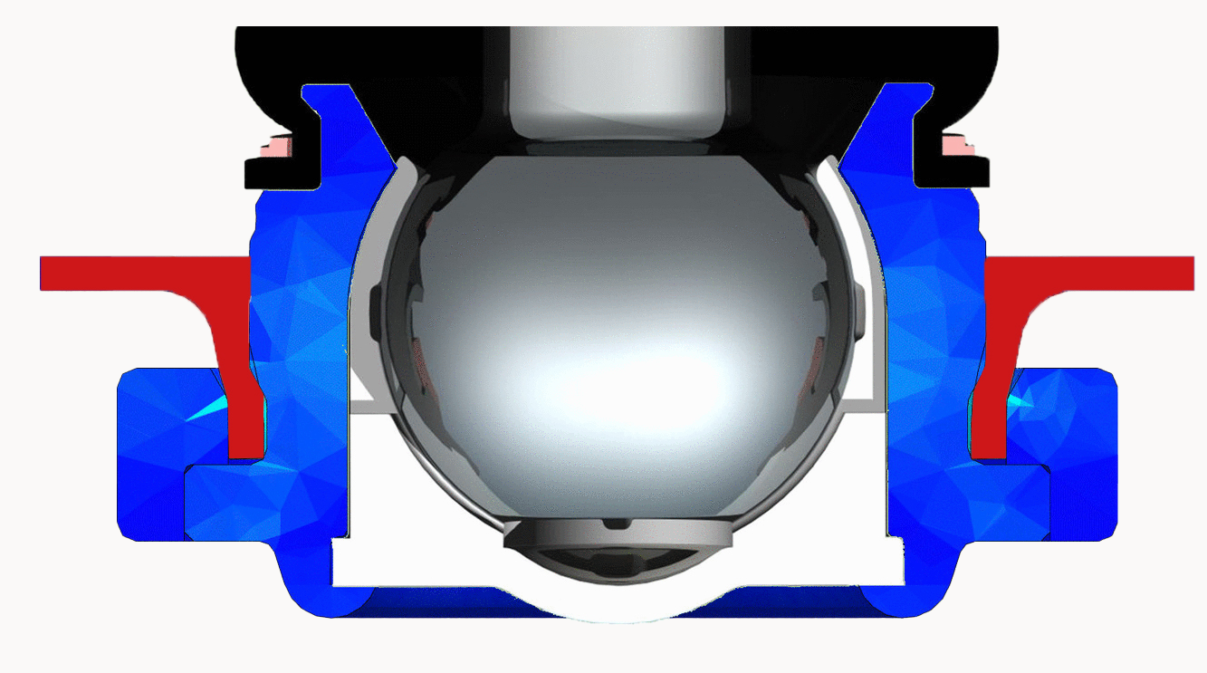
The press ball joint is designed in such a way that the part locks itself when you press it into the OEM control arm. How? Well, the ball joint has a wide collar on the outside. As soon as it slides over the edge of the control arm, the ball joint will lock itself. You can compare it to how a barb functions. You slide the part in easily, but the part cannot return. The ball joint is fully secured in the control arm. In other words: you can use Sidem’s solution to replace the ball joint in the OEM control arm in an easy and safe way.

What not to do when replacing a press ball joint
Replacing the ball joint separately and welding it is certainly not an option. Doing so will melt the dust cover and plastic insert, causing the part to break completely. You can buy separate ball joints in the aftermarket but most of them do not guarantee a fully secured installation. In situation like these, safety is at risk.

Safe an easy solution
Ball joints are one of the pillars of Sidem’s product range. We can list several features that characterize our ball joints but selected the most important ones for you.
- All ball pins and studs are made of chromium steel. This not only ensures maximum strength of the part but also prevents the part from breaking at extreme impact.
- The ball joint dustcover consists of chloroprene rubber, which as a maximum resistance to chemical substances. It also offers the best sealing from moist and dust.
- The dustcover seat is a specially designed one, that prevents the dustcover from collapsing.
- The shape of the dustcover is specially designed and prevents it from twisting.
- When it comes to the housing of our ball joints, you’ll see there is no cutting in the steel micro-structure or the thread. Rolling it ensures a stronger one. The finishing of the housing has no sharp edges but rounded ones, that prevent damage.

Ball joint references for Dacia, Lada, and Renault
We have two ball joint references in our range that can help you fix this problem.
- 5782 R for Dacia Logan, Dacia Sandero and Lada Largus
- 5783 R for Renault Thalia, Dacia Lodgy and Dacia Logan MCV 2.

For technical specifications, visit www.sidem.eu.

IMAGES

Patented ball joint for certain models of Renault, Dacia,
Lada by Sidem.

The press ball joint is designed in such a way that the part
locks itself when you press it into the control arm

ABOUT SIDEM

Sidem is the leading designer and manufacturer of steering and suspension car parts for the assembly and aftermarket automotive industry. The family-owned company, existing since 1933, offers more than 9000 references. Over 3 million items for almost all European and Asian car brands are available from stock. Sidem is the specialist in OE quality steering and suspension car parts with an own R&D, production and logistics center based in Europe.

www.sidem.eu

PRESS CONTACT

Steven Meeremans
T. (+32) (0)56 43 54 66
press@sidem.eu

