Meeting the trends in the electrical car industry with Sidem’s specialized product range

___________________

- Sidem offers 960 unique references available from stock for 32 BEV brands (Private Cars (PC) and Light Commercial Vehicles (LCV). This is a coverage of 83,66%, the highest score within the steering and suspension aftermarket.
- Steering and suspension parts for Battery Electrical Vehicles (BEVs) have to be extra strong because they are subject to the higher weight of the car and its faster acceleration (torque). In addition, they are designed with a focus on lower noise production compared to parts for Internal Combustion Engines (ICE). A few examples of Sidem’s interventions on BEV components:
  - Ball pins with a bigger diameter embedded in ball joints, axial joints and stabilizer links;
  - Track control arms with an incorporated ball joint in the aluminum housing;
  - Silent blocks with an extra metal ring or hydraulic spaces for higher driving comfort;
- Now available for download: Sidem’s BEV car catalogue with detailed product overview and technical information of all BEV parts ranked by brand and model.

___________________

With the shift towards low emission zones and the EU’s demand for CO2 neutrality by 2035, the automotive industry is rapidly moving towards electric vehicles. Therefore, Sidem has developed an extensive range of specialized parts for Battery Electrical Vehicles (BEVs). The leading designer and manufacturer of steering and suspension parts for the aftermarket automotive industry has developed these parts with a focus on stronger design, minimal road noise and safe installation.

As more and more cities introduce low emission zones and the European Union demands that all new cars be CO2 neutral by 2035, the shift towards electrification in the automotive sector is inevitable. The number of electric vehicles in Europe has risen from 1% in 2017 to 9% in 2021, according to CLEPA (European Association of Automotive Suppliers). Furthermore, the World Economic Forum predicts that there will be 300 million electric vehicles in use in the U.S. by 2030.

Highest aftermarket coverage
Sidem’s range of BEV steering and suspension parts includes 960 unique references for 32 European and Asian brands, covering 83.66% of the aftermarket. No other company has this amount of relevant coverage for steering and suspension parts tailored to BEVs in the nineteen countries where Sidem is active.

Stronger design
Despite the shift towards electric vehicles, the impact on the aftermarket for steering and suspension parts is relatively limited. However, BEVs are heavier than petrol cars due to their battery pack, which puts extra stress on the steering and suspension parts. Sidem’s range of BEV parts has been engineered to handle this additional weight and torque, ensuring maximum strength and safety.

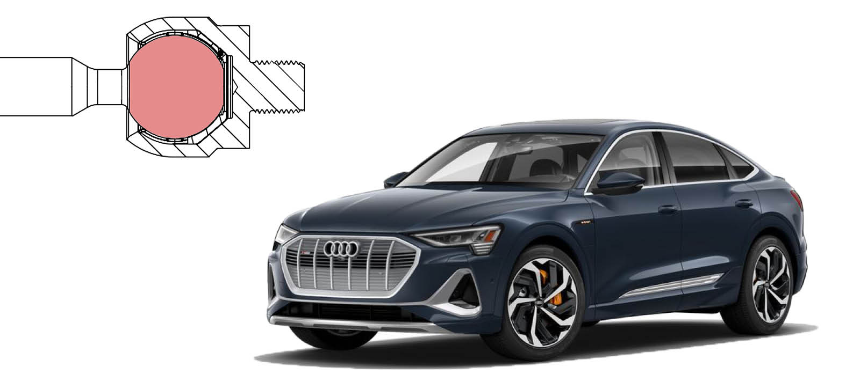

The range of BEV parts includes ball pins made of chromium steel (42CrMo4V), which ensures maximum strength and prevents breakage at extreme impact. The diameter of the ball pins is also important for handling the heavy load and higher torque of BEVs. Sidem’s ball pins for BEVs have a larger diameter than those for Internal Combustion Engine (ICE) cars. The axial joints of several Tesla models feature even larger ball pin diameters than original equipment parts for extra resistance to high stress, providing extra safety and a longer lifespan.

Specialized parts
BEVs place a greater emphasis on aerodynamics to improve efficiency and extend the driving range. As a result, the suspension system is designed to maintain the vehicle's optimal aerodynamic profile by minimizing body roll during cornering. Sidem’s range of stabilizer links, which have ball joints on both sides, has larger ball pin diameters for BEVs compared to similar ICE models.
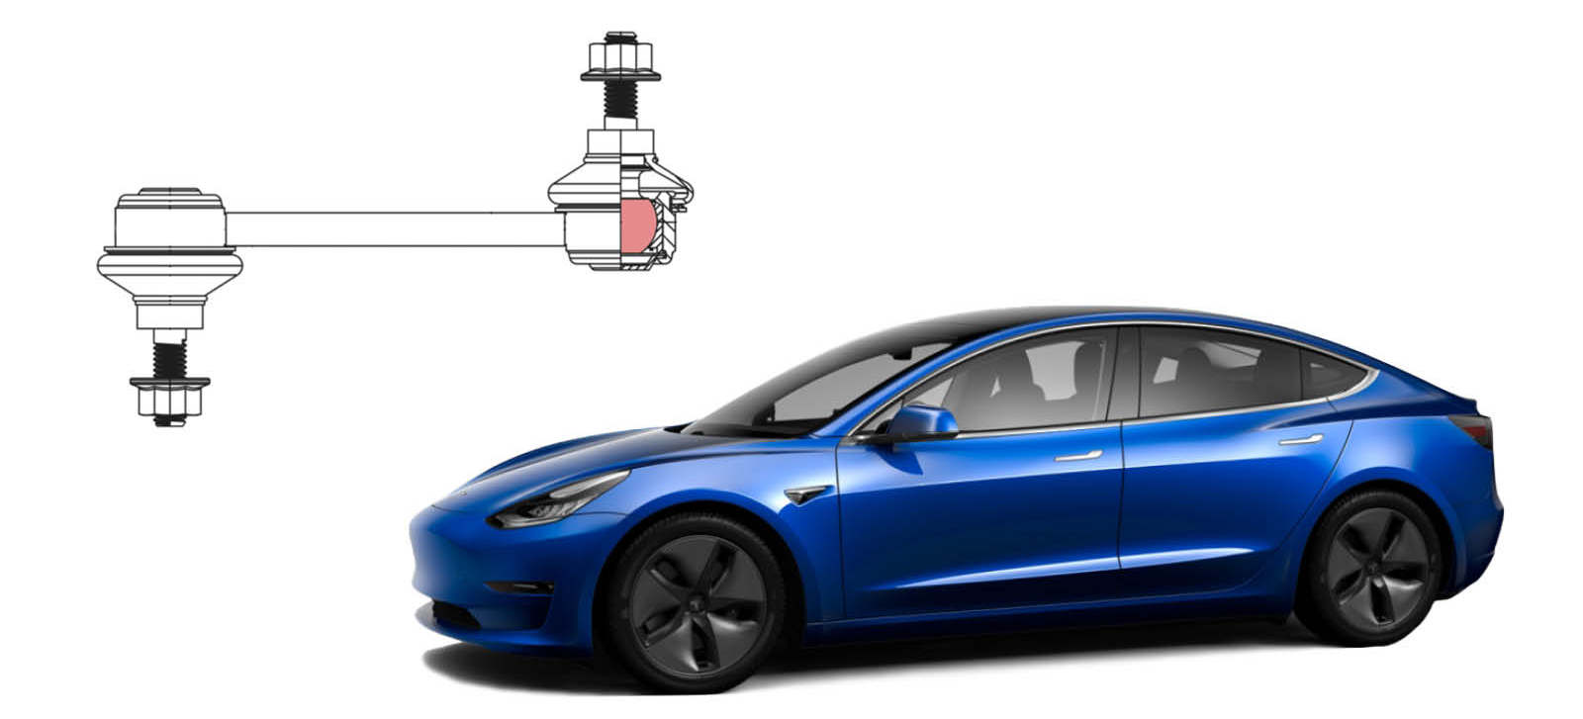

If we look at a common petrol car like the BMW 3 series, the diameter of the Sidem part is 20mm while original equipment only specifies a diameter of 19mm. Compared to the same part for a Tesla Model 3, a similar BEV car, the ball pin is even bigger with a diameter of 22mm (original equipment and Sidem). This is an important factor to secure the stabilizer link to withstand the heavy load and the higher torque of battery electrical cars.

Minimal road noise
Finally, BEVs produce less noise and vibration than combustion engines, leading to a greater focus on minimizing road noise and vibrations transmitted to the cabin. Sidem’s range of silent blocks supports movement and isolates vibrations and noise for a higher driving comfort.

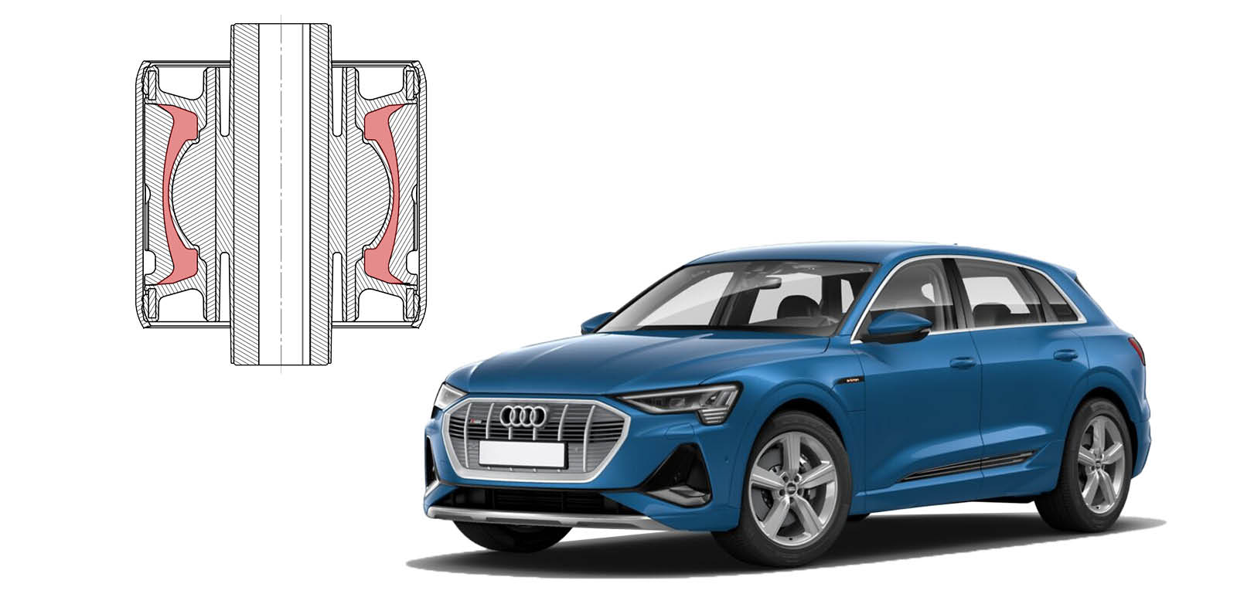

Safer installation
Sidem also offers a track control arm with a different design as a solution to the problem of weak link ball joints. The ball joint of Sidem’s track control arm for the first generation Tesla models is incorporated directly into the aluminum housing, resulting in the part functioning with maximum strength. This ensures a safe installation and drive.
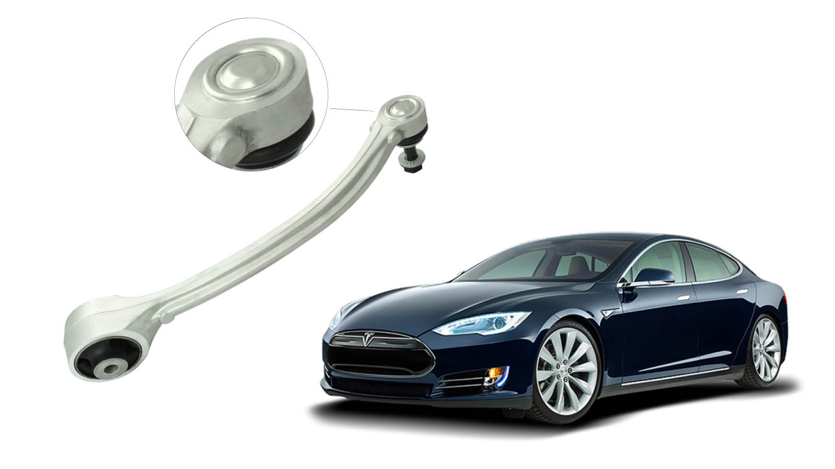

With its extensive range of references for electric vehicles and specialized design for steering and suspension parts, Sidem is leading the way in meeting the trends in the electrical car industry. Both in relevant coverage (available products) as the quality of the products (with at least original equipment parts for reference).

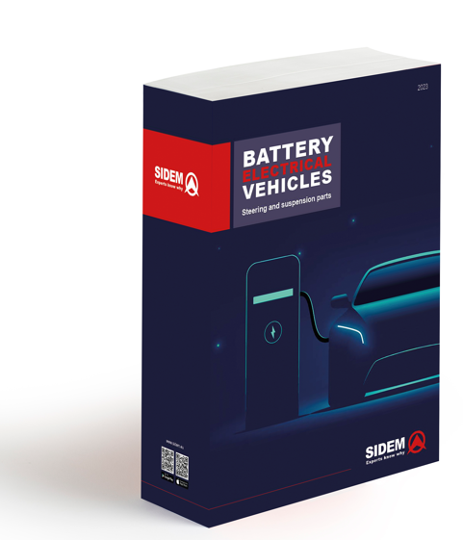
Catalogue BEV
In May 2023, Sidem launched a catalogue dedicated to their range of steering and suspension parts, specifically for Battery Electrical Vehicles. Download here for free.

For more information on Sidem's range of steering and suspension parts for BEVs and other vehicles, please visit www.sidem.eu.

ABOUT SIDEM

Sidem is the leading designer and manufacturer of steering and suspension parts for the aftermarket automotive industry. The family-owned company, existing since 1933, offers more than 9000 references. Over 3 million parts for almost all European and Asian car brands are available from stock. Sidem is the specialist in OE quality steering and suspension parts with its own R&D, production and logistics center based in Europe.

www.sidem.eu

PRESS CONTACT

Steven Meeremans
T. (+32) (0)56 43 54 66
press@sidem.eu

www.sidem.be/press

